Lesson 4 Demo 4: Post-Build Actions

This section will guide you to:

* Configure post-build actions

This lab has two sub-sections, namely:

1. Configuring SMTP settings to enable email alerts in Jenkins

2. Defining post-build actions in a build and testing the SMTP settings

**Step 1:** Configure SMTP settings to enable email alerts in Jenkins

* Go to Jenkins **dashboard**.
* Click on ***Manage Jenkins*** in the Jenkins dashboard and select ***Configure System***.

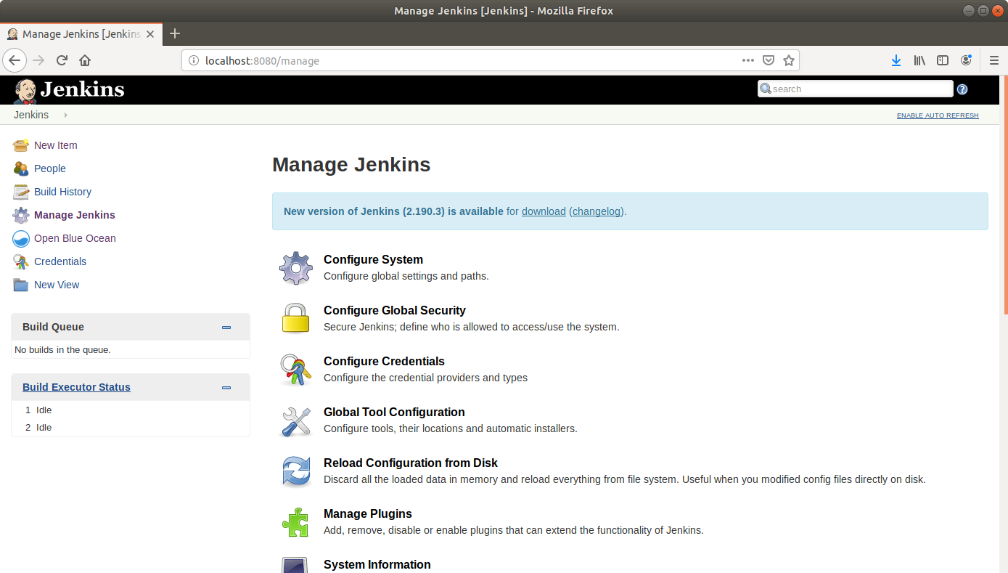

* Scroll down to the end of the page to the ***Email Notification*** section.
* Click on the ***Advanced***button to reveal advanced settings.
* Fill the fields with appropriate values as shown below:

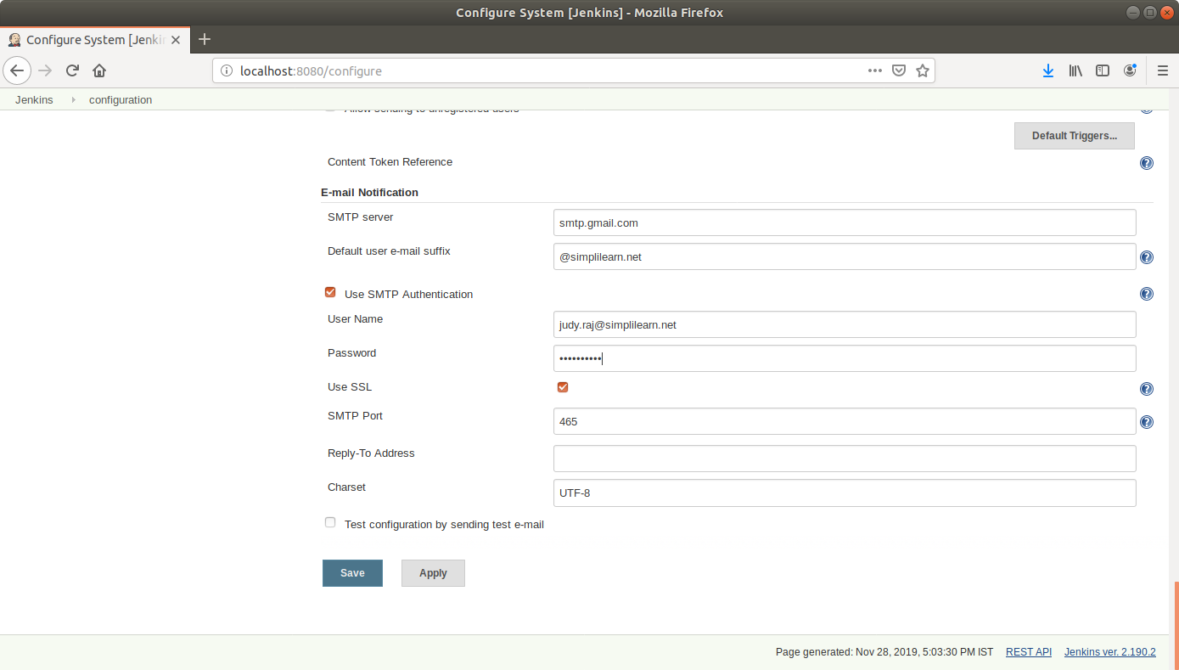

**SMTP server**: smtp.gmail.com

**Default user email suffix**: @gmail.com

**User Name**: <your email Id>

**Password:** <your password>

**Tick** the Use SSL checkbox

**Port**: 465

* Select the ***Test configuration*** *by sending test e-mail* and enter a recipient email to test the configuration.
* **Note:** In case your test configuration mail fails reporting **Authentication Error: Bad password** you will have to make sure that you have turned the **Allow Less secure Apps: ON** in your google account settings.
* Click ***Save***

**Step 2:** Defining post-build actions in a build and testing the SMTP settings

* Go to Jenkins **dashboard**.
* Click on ***New Item***.
* Enter a **name** for your build job.
* Select ***Freestyle project***as the build job type.

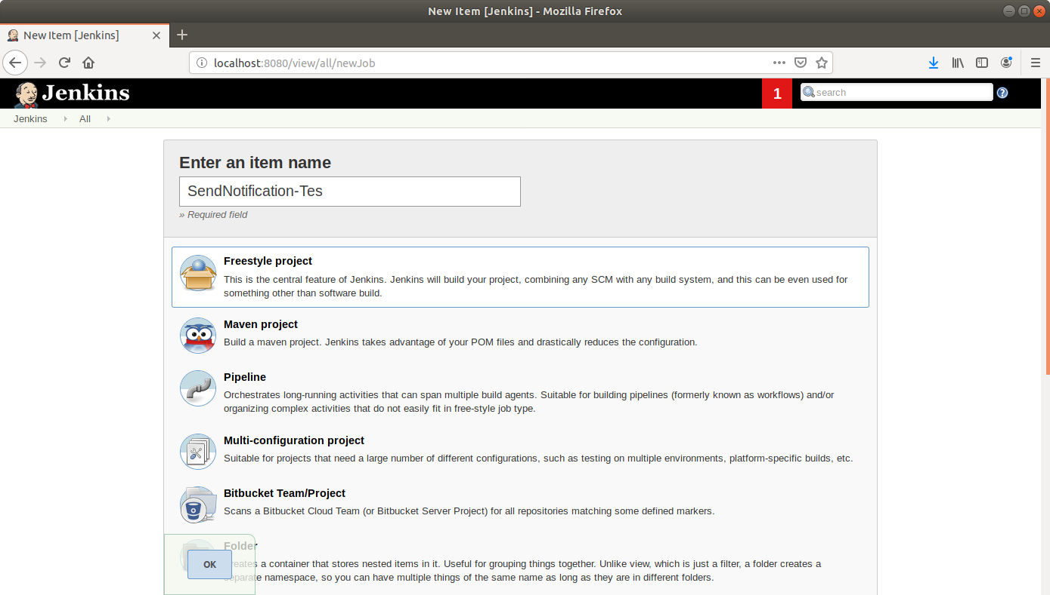

* Click **OK**.
* Scroll down to the **Source Code Management** section and select ***Git***.
* Enter the link to the repository in the field that appears.

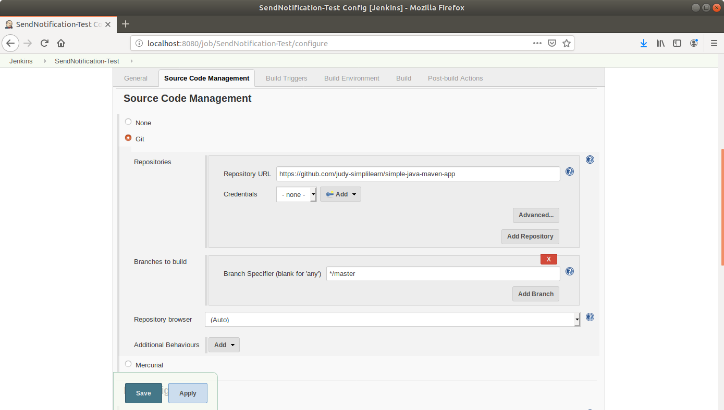

* Scroll down to the***Build*** section and click on ***Add build step***.
* Select***Execute Shell***from the drop down that appears.
* Enter the following maven command in the textbox that appears:  
  **mvn compile**

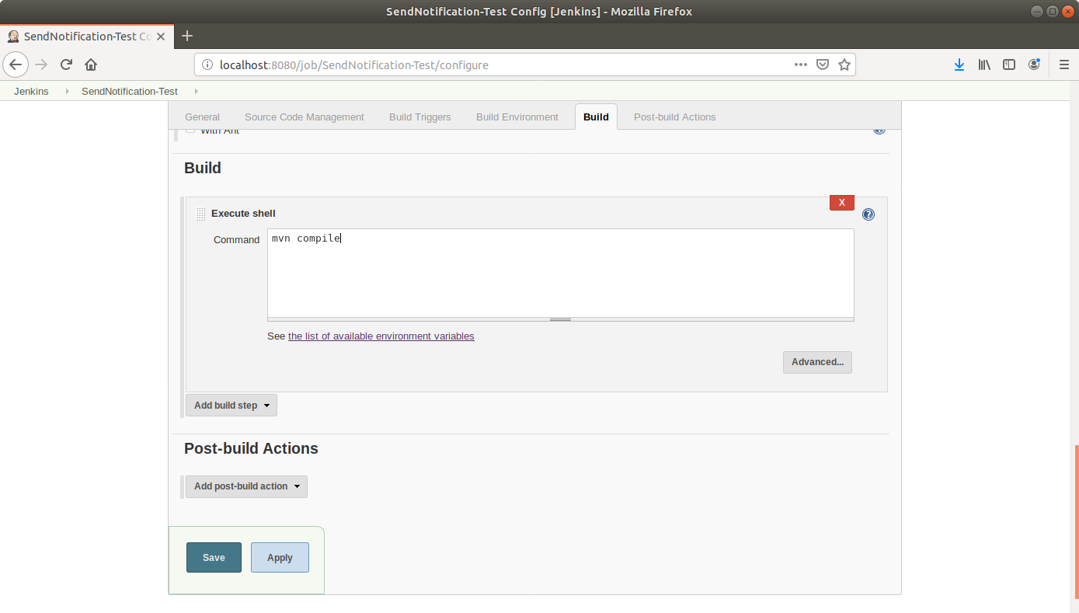

* Scroll down to the ***Post-build*** *Actions* tab and click on the ***Add post-build******action*** button.
* From the drop down, select ***Email notification***and fill the recipient address in the textbox that appears.

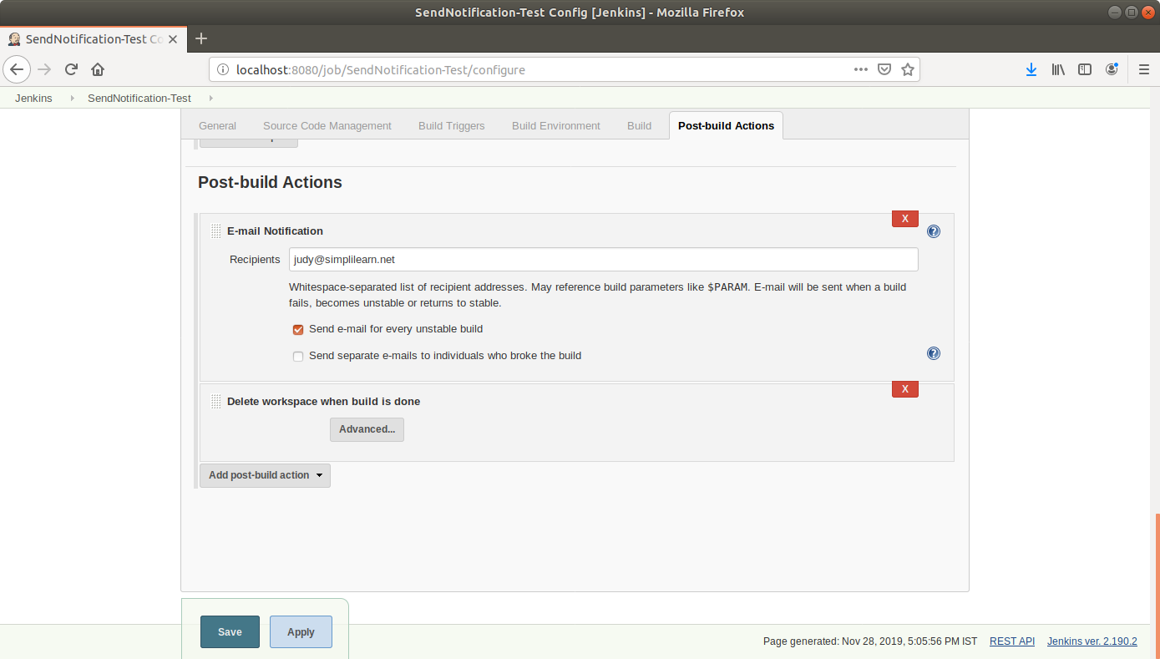

* Click on the ***Add post-build action***button.
* From the drop down, select ***Delete workspace*** *when build is done*.
* Click **Save**.
* Introduce an error in the Maven project to be built and commit to Git. An extra build tag is added in the **pom.xml** below.

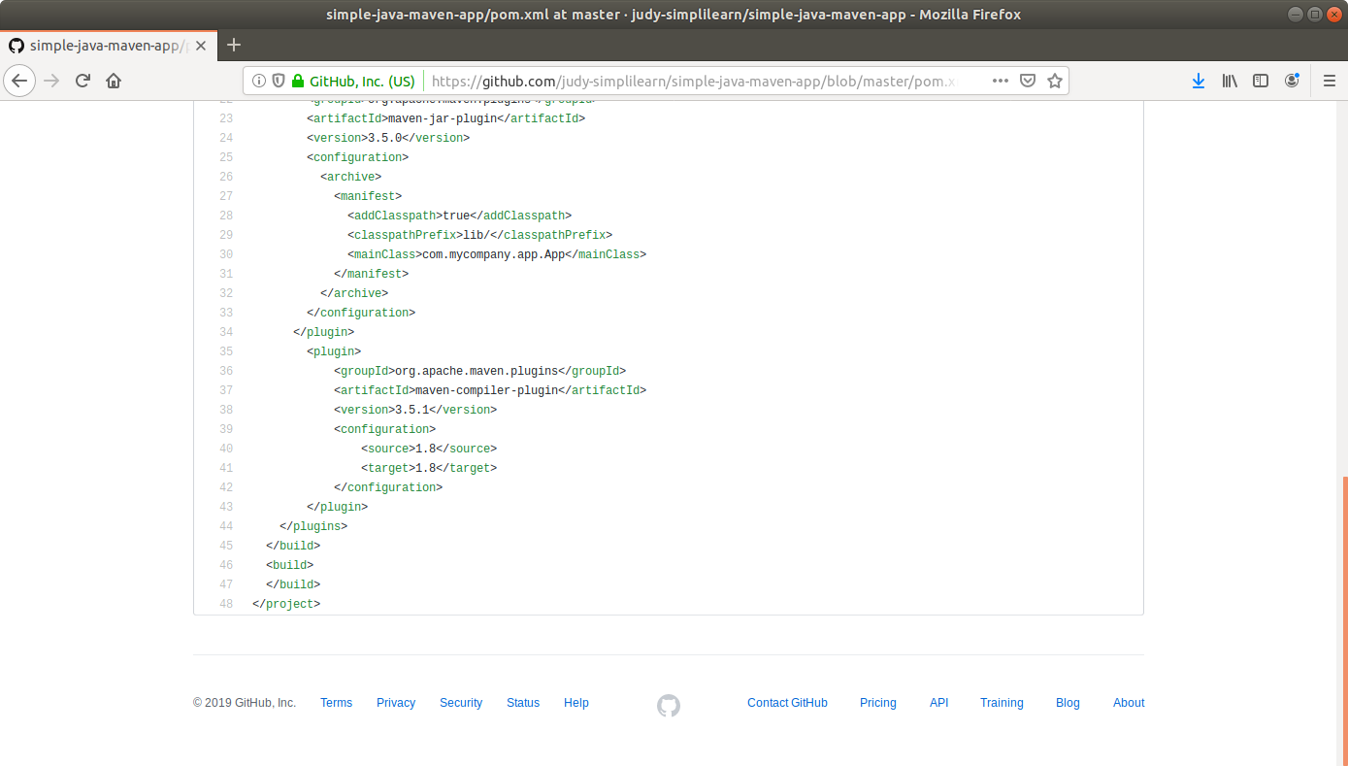

* Click ***Build Now*** in the project window to make sure that the build works. Jenkins will now build your project.
* Click on the ***Build History***to view the build results.
* Click on the ***Console Output*** to view the build logs.

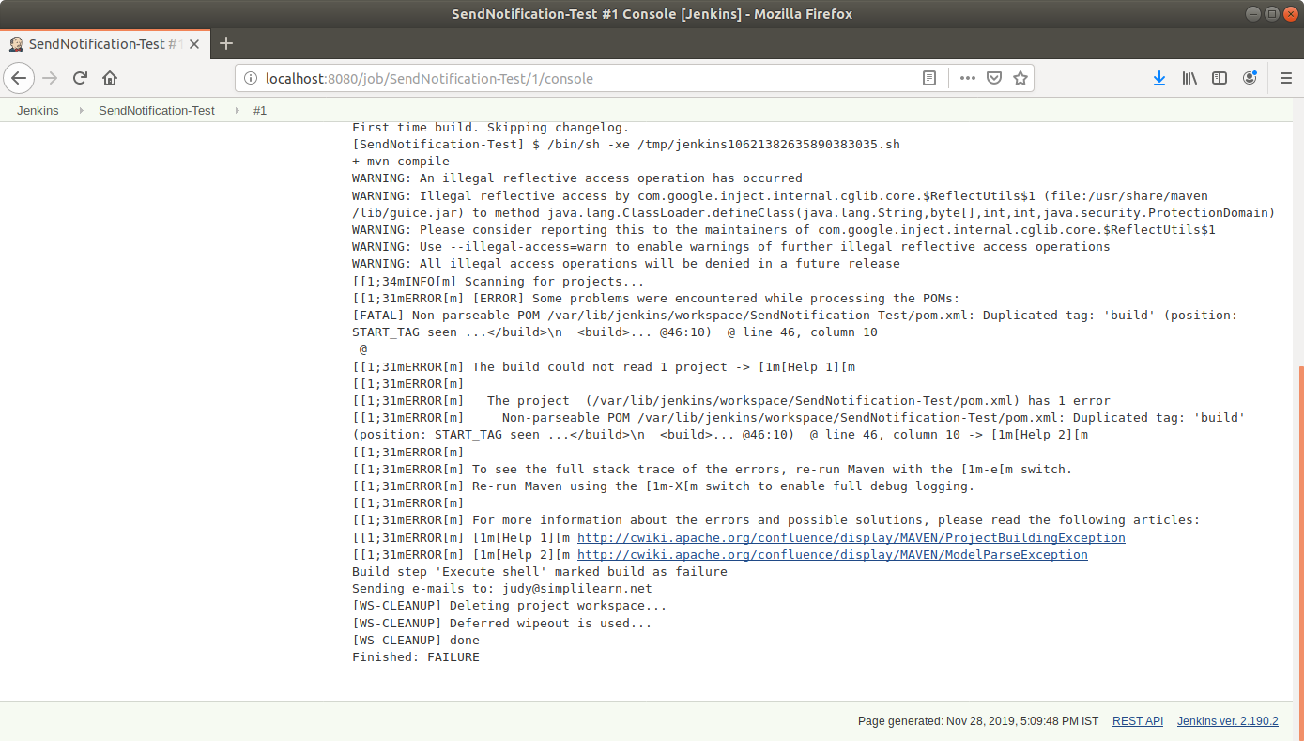

* Check the **email** to see the notification.

